An Energy Sources Modell

1.A Large-cycling of time(t), space(v), matter(m) and energy(E)
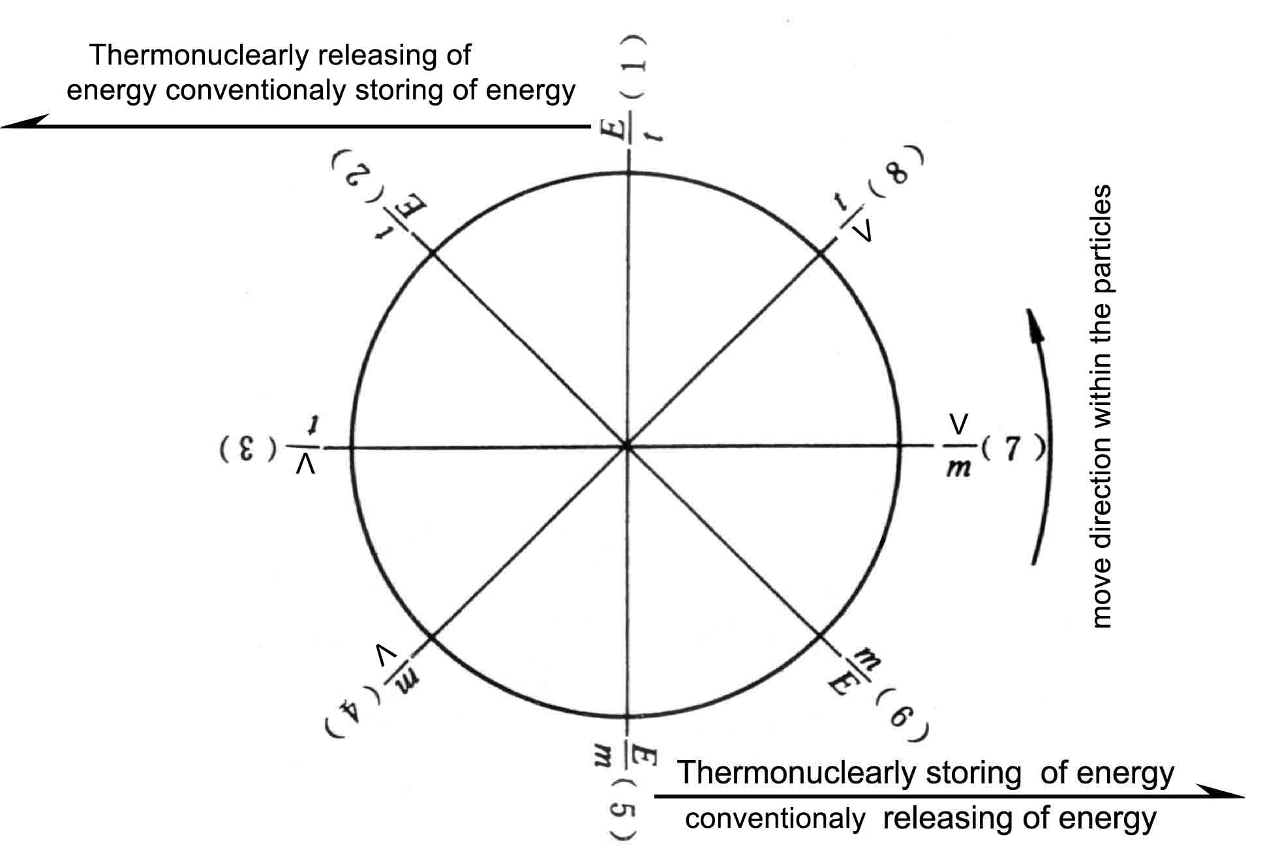
$\frac{y}{x}$––conversion factors (8 in all).
2.The gravity law holds in the above mentioned model when $\frac{V}{t}=\frac{m}{V}$
$\frac{F3}{F3}⋅\frac{V}{t}=\frac{m4}{V}(F=\text{ma},a=\frac{V}{t^{2}},v=\frac{V}{t})$
then $F_{3}=\frac{m_{3}m_{4}}{V^{2}}(\frac{V}{t})$
3.Gaussian Law (electro-magnetic law) holds also in the one and the same model.
$\begin{aligned}\frac{F_{7}}{F_{7}}⋅\frac{V}{m}=\frac{m_{6}}{E_{6}}(E=F⋅V) \\ F_{7}=\frac{m_{7^{2}}}{V^{2}}\end{aligned}$
4.There are two “poles” in the model.
$I\text{f }F_{1−3}⋅\left(1\right)=\left(3\right)⋅F_{1−3},\text{then }F_{1−3}=\text{1 },\text{ and if }F_{4−6}\left(4\right)=\left(6\right)⋅F_{4−6},\text{then }F_{4−6}=\text{1 }$
this shows that between $F_{1−3}$ and $F_{4−6}$there is neither the Particle movement nor the field action. The particles in the both parts of the model can only go from (1) via (2) to (3) or from (4) via (5) to (6), respectively. But they can not leap over the limit of (5) and (6). Therefore, the limits of (1) and (6) and of (5) and (6) are the “poles” in the particles set.
5.From the above-mentioned, it may be known that there are 16 foroes (or fields) in the direct cycling and the reverse cycling, i. e.
$\begin{aligned}F_{1}=\frac{t}{m_{2}}{\left(\frac{t}{V}\right)}^{3},F_{2}=\frac{m_{2}^{2}}{t^{2}}{\left(\frac{V}{t}\right)}^{4},F_{3}=\frac{m_{3}m_{4}}{V^{2}}\left(\frac{V}{t}\right) \\ F_{4}={\left(\frac{V}{t}\right)}^{4},F_{5}=\frac{m_{5}}{V}{\left(\frac{t}{V}\right)}^{2},F_{6}=\frac{m_{6}}{m_{7}}{\left(\frac{V}{t}\right)}^{4}, \\ F_{7}=\frac{m_{7}^{2}}{V^{2}}\left(\frac{V}{t}\right),F_{8}=\frac{m_{1}m_{8}}{t^{2}}{\left(\frac{V}{t}\right)}^{4}, \\ F_{2}^{'}=\frac{m_{1}m_{2}^{2}}{t^{3}}{\left(\frac{V}{t}\right)}^{5},F_{3}^{'}=\frac{m_{3}}{m_{2}}{\left(\frac{t}{V}\right)}^{2},F_{4}^{'}={\left(\frac{V}{t}\right)}^{3}, \\ F_{5}^{'}=\frac{m_{4}m_{5}}{V^{2}},F_{6}^{'}=\frac{m_{6}}{t}{\left(\frac{V}{t}\right)}^{5},F_{8}^{'}=\frac{m_{7}^{2}}{V^{2}}\end{aligned}$

(Known)

$F_{8}^{'}=\frac{m_{8}}{m_{1}}{\left(\frac{V}{t}\right)}^{3},F_{1}^{'}={\left(\frac{t}{V}\right)}^{2},$ (Known)
Above-mentioned 16 small fields make each $\frac{y}{x}$ span, and construct a larg field, so that the large-cycle rotates as a whole with the pole as presentation.
6.Formulas of the large-cycling
(1) $V=\frac{V}{t}=C$
(2) $ε=\frac{E}{m}=C^{2}$
(3) From $F=\frac{m_{3}m_{4}}{V^{2}}⋅\left(\frac{V}{t}\right)$ and $\frac{E}{m}=C^{2}$ we may obtain $r=\frac{m}{V}=C$
- and with (3) also may obtain $N=v⋅r⋅ε=\frac{E}{t}=C^{4}$ .
- $$\frac{1}{N}=\frac{1}{v⋅r⋅ε}=\frac{1}{C^{4}}$$
Now that (4)(5)=1,a large – cycling is completed ,that is ,$e^{2πi}=1$ .
7.The constant of the large-cycling
$$K=\left[C^{4}+C^{2}+2C\right]+\left[C^{−4}+C^{−2}+2C^{−1}\right]$$
8.The construction of the large-cycling through the transfor mation of the conventional and the thermonuclear energy.
$\frac{E}{m}$the matter m possesses energy E;
$\frac{m}{E}$a new matter m is formed by combustion of energy E;
$\frac{V}{m}$the new matter m expands to V that is, a certain amount of the momentum is given to it.
$\frac{t}{V}$the momentum obtained by the new matter possesses a impulse t.
$\frac{E}{t}$the impulse had done the work E through the “poles”.
The above-mentioned are exactly the kinetic laws of conventional energy (such as that in the interal-combustion engine).
In this model the existance of the gravity has showed the left part of the model presents the kinetic laws of thermonuclear energy.
The conventional energy released is just the thermonuclear-energy store and the reverse is also true. Therefore, if there were not any thermoreactions. There would not be any thermoenergitic sources, any thermodynamic reactions and any thermonuclear-energy sources. In other words, the conventionalreaction is just in making the thermonuclear-energy sources, and the thermoreaction, just in making the conventional-energy sources. Both the conventional and the thermonuclear reaction are supple-ment each other. Thus, we have found out the space-scale “perpentual machine”.
The spontaneous combustion of the conventional energy and the spontaneous fission or the fusion of the thermonuclear-energy are the natures of the natural world and independent from the man's action. The mankind should try to maintain the dynamic equilibrium of the earth's energy. Once the equilibrium is destroyed, the thermonuclear-energy may be. stored may be stored up to a critical value, and then the spontaneous explosion would take place. So far it has been observed that Jupiter has already come to radiate out its energy, thus, it is extremely urgent to understand and control the earth fairly. well.
9.In summarizing the above-mentioned, the celestial bodies, the natural objects in space, and the particle intension and extension seem similar to the model.

